F2F(20)7648:2-FG/sm
To the Members of the Copa and Cogeca Task Force on the Farm to Fork Strategy

Brussels, 27th October 2020

Dear Sir or Madam,
You are invited to attend the video-meeting of the Copa and Cogeca Task Force on the Farm to Fork Strategy which will be taking place on :

Wednesday 28th October 2020
from 3.00 p.m. to 6.00 p.m.

Please register by clicking on this link.

Agenda
- Approval of the agenda
- Approval of the minutes of the meeting of the Task Force held on 27th February 2020 F2F(20)2847 (rev.1)
- Exchange of views with Tassos Haniotis (Director, Strategy, Simplification and Policy Analysis, DG AGRI, European Commission) on the implementation of the Farm to Fork Strategy COM(20)3433 (rev.1); F2F(20)4788 (rev.1)
- Exchange of views with Mr Herbert Dorfmann, Member of the European Parliament, co-rapporteur of the EP initiative report on the Farm to Fork Strategy
- Exchange of views with Ms Anja Hazekamp, Member of the European Parliament, co-rapporteur of the EP initiative report on the Farm to Fork Strategy
- Any other business

Best regards,
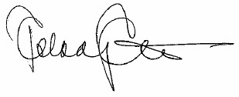
Pekka Pesonen
Secretary General

