POCC(20)6893:1-FG/sm

To the Members of the Policy Coordination Committee of Copa and the Cooperative Coordination Committee of Cogeca

Brussels, 24th September 2020

Dear Sir or Madam,
You are invited to take part in the next jointly “Weekly” video-meeting of the POCC and the CCC which will be taking place on

Wednesday 30th September 2020
from 12.00 p.m. to 1.00 p.m.

Please register here.

Agenda
- Approval of the agenda
- Union’s budget, transition regulation and CAP post 2020 PAC(20)6892 (rev.1); BUD(20)5310 (rev.3); PAC(20)4919 (rev.2); PAC(20)6896 (rev.1)
  - Information update on the state of play of negotiations at Council and European Parliament
  - Exchange of views and preparation of lobbying actions
- Any other business

Best regards,
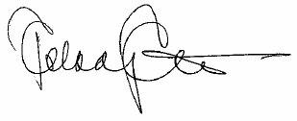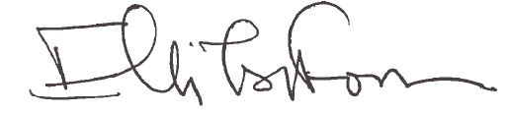
Pekka Pesonen Elli Tsiforou
Chair of the POCC Chair of the CCC

