POCC(20)2671:1-FG/sm

To the Members of the Policy Coordination Committee of Copa and the Cooperative Coordination Committee of Cogeca

Brussels, 27th April 2020

Dear Sir or Madam,
You are invited to take part in the next jointly “Weekly” meeting of the POCC and the CCC which will be taking place via video-conference

Thursday 30th April 2020
from 12.00 a.m. to 1.30 p.m.

Agenda

- Debriefing of the exchange of views with Commissioner Wojciechowski on the Covid-19 outbreak held during the joint Praesidia on 22nd April
- Information and exchange of views on the Covid-19 outbreak impact COV(20)2738 (rev.1); COV(20)2472 (rev.1); COV(20)2605 (rev.2); CC(20)2540 (rev.1); CC(20)2587 (rev.2); EA(20)2152 (rev.2)

Best regards,
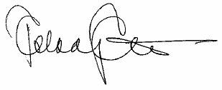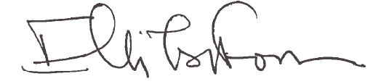
Pekka Pesonen Elli Tsiforou
Chair of the POCC Chair of the CCC

