POCC(20)2138:1-FG/sm
To the Members of the Policy Coordination Committee of Copa and the Cooperative Coordination Committee of Cogeca

Brussels, 31st March 2020

Dear Sir or Madam,
You are invited to take part in the next jointly “Weekly” Meeting of the POCC and the CCC which will be taking place via video-conference

Friday 3rd April 2020
from 12.00 p.m. to 1.30 p.m.

Agenda

- Approval of the agenda
- Approval of the minutes of the POCC/CCC “Monthly” held on 12th March 2020 POCC(20)1831 (rev.1)
- Information and exchange of views on the Covid-19 outbreak:
  - Impact on the agricultural, forestry and fisheries sector CC(20)1809 (rev.1); CC(20)1814 (rev.1); CC(20)1807 (rev.1); COV(20)2000 (rev.1); DIS(20)2030 (rev.1); COV(20)2031 (rev.1); CDP(20)2061 (rev.1); COV(20)2113 (rev.1)
  - Guidelines concerning the exercise of the free movement of workers during COVID-19 outbreak EA(20)2115 (rev.1)
  - Copa and Cogeca draft letter on the flexibility on the commission regulation regarding fruit and vegetables producers organisations FL(20)2097 (rev.2)
- Information and exchange of views on the European Green Deal:
  - EU Biodiversity Strategy 2030 CC(20)1825 (rev.1)
  - European Climate Law EN(20)1908 (rev.1)
  - Taxonomy Regulation SF(20)2044 (rev.1)
  - Farm to Fork Strategy
  - Carbon Border Adjustment Mechanism EN(20)2015 (rev.1)
- Information on the outcome of the Copa and Cogeca Finance and Management Committee meeting held on Monday 23rd March 2020 FM(20)1776 (rev.1); FM(20)1777 (rev.1); FM(20)1778 (rev.1)
- Any other business

Please take notice that it will take place in English only.

Best regards,
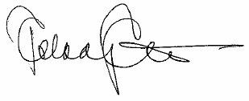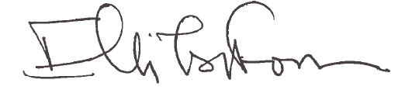
Pekka Pesonen Elli Tsiforou
Chair of the POCC Chair of the CCC

