POCC(20)3673:1-FG/sm

To the Members of the Policy Coordination Committee of Copa and the Cooperative Coordination Committee of Cogeca

Brussels, 29th May 2020

You are invited to take part in the next jointly “Weekly” video-meeting of the POCC and the CCC which will be taking place on

Tuesday 2nd June 2020
from 2.00 p.m. to 3.30 p.m.

Agenda

- Approval of the agenda
- Preparation of the joint Praesidia meeting: exchange of views with Commissioner for Agriculture Wojciechowski on the Multiannual Financial Framework (MFF) 2021-2027 BUD(20)3627 (rev.1)
3. Any other business

Best regards,
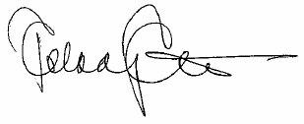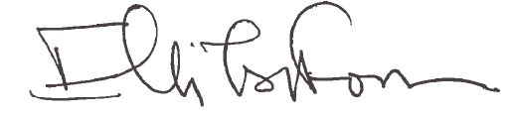
Pekka Pesonen Elli Tsiforou
Chair of the POCC Chair of the CCC

